Welcome to Elastic Cloud Infrastructure: Scaling and Automation Apr 15, 2026
This course, "Elastic Google Cloud Infrastructure: Scaling and Automation," focuses on advanced architecting with Google Cloud's Compute Engine and related services.
Course Overview
- It builds on foundational courses to deepen understanding of Google Cloud infrastructure and platform services.
- The course emphasizes scalable and automated cloud infrastructure solutions.
Key Modules
- Interconnecting Networks: Learn options to securely connect your infrastructure to Google Cloud.
- Load Balancing and Autoscaling: Explore Google Cloud's services to distribute traffic and automatically scale VM instances.
Automation and Managed Services
- Infrastructure Automation: Use tools like Terraform to automate deployment of cloud infrastructure.
- Managed Services: Discover additional Google Cloud managed services to enhance your infrastructure.
The course combines video lectures, demos, and hands-on labs to provide practical experience in deploying and managing scalable cloud infrastructure.
Module Overview Apr 15, 2026
This course module introduces the concept of interconnecting networks within Google Cloud Platform (GCP) to support various applications and workloads.
Hybrid Connectivity Solutions
- GCP offers multiple ways to connect your infrastructure to the cloud, tailored to different needs.
- The focus is on hybrid connectivity products such as Cloud VPN, Cloud Interconnect, and Peering.
Network Sharing and Practical Exploration
- The module also covers options for sharing Virtual Private Cloud (VPC) networks within GCP.
- Learners are encouraged to explore Cloud VPN through a hands-on lab to understand its implementation.
Cloud VPN Apr 15, 2026
This course content explains the two types of Google Cloud VPN gateways—Classic VPN and HA VPN—and their configurations for securely connecting on-premises networks to Google Cloud VPC networks.
Types of Cloud VPN Gateways
- Classic VPN connects on-premises networks to Google Cloud VPCs using IPsec tunnels, encrypting traffic for secure transmission over the public internet, suitable for low-volume data connections with 99.9% SLA.
- HA VPN offers high availability with a 99.99% SLA, using two external IP addresses and multiple tunnels per gateway interface, supporting dynamic routing and redundancy configurations.
VPN Gateway Configurations and Use Cases
- Classic VPN requires two tunnels between gateways and supports static and dynamic routes via Cloud Router.
- HA VPN supports site-to-site VPN with configurations such as connecting to multiple peer devices, AWS virtual private gateways, or other HA VPN gateways for redundancy and failover.
Dynamic Routing with Cloud Router
- Cloud Router manages dynamic routes using BGP, allowing automatic route updates without changing tunnel configurations.
- BGP sessions use link-local IP addresses to advertise new subnets seamlessly between Google Cloud and on-premises networks, facilitating network growth and traffic management.
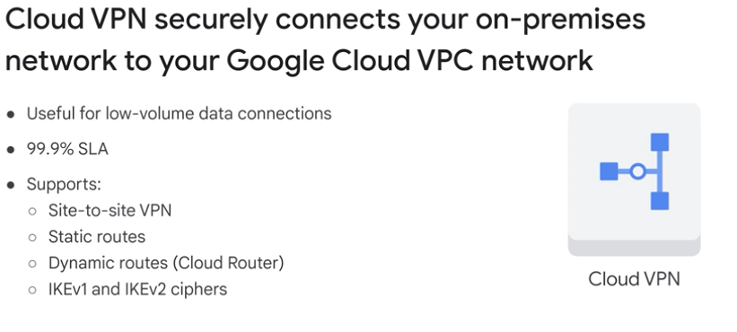
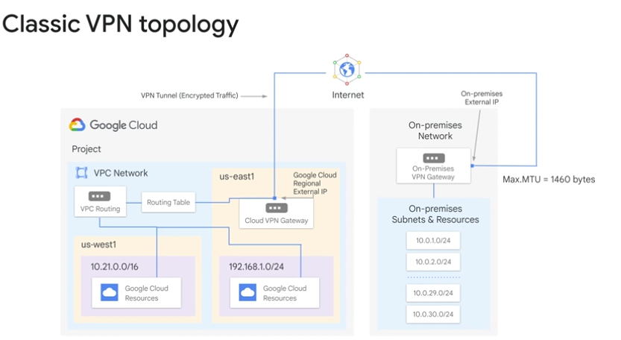
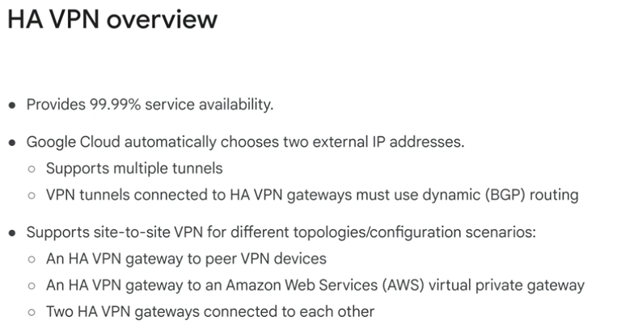
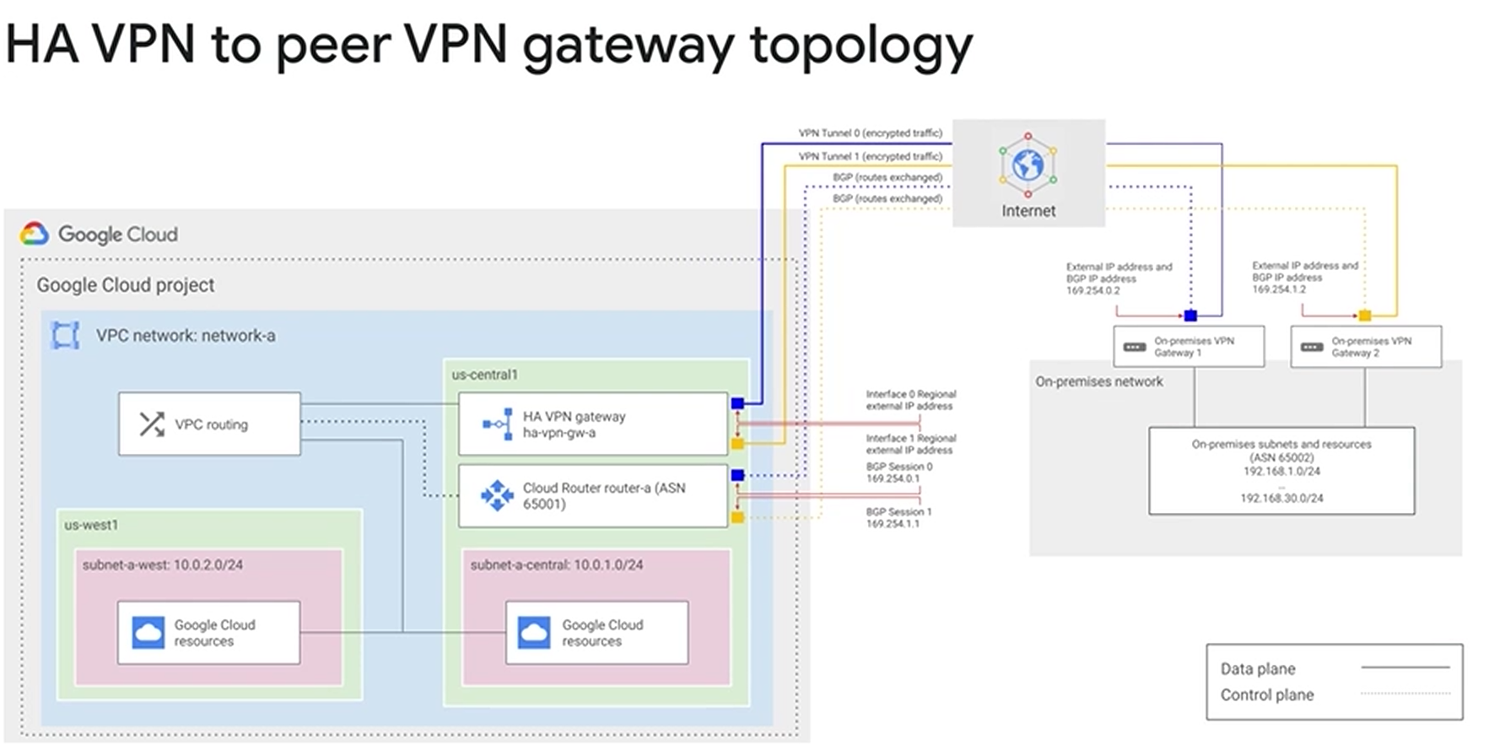
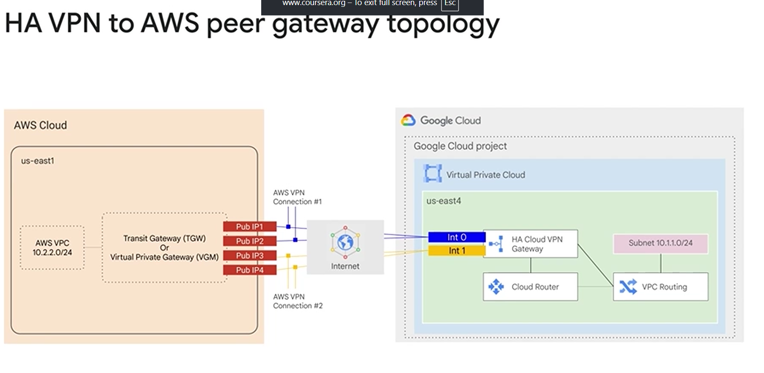
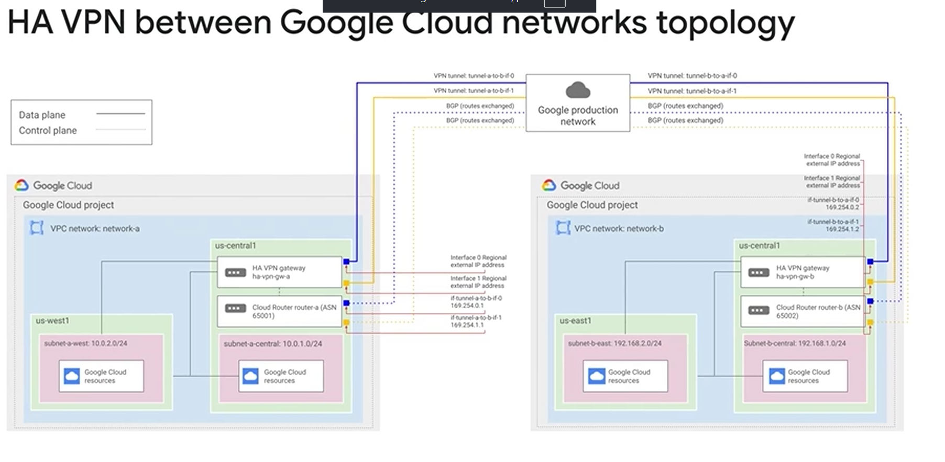
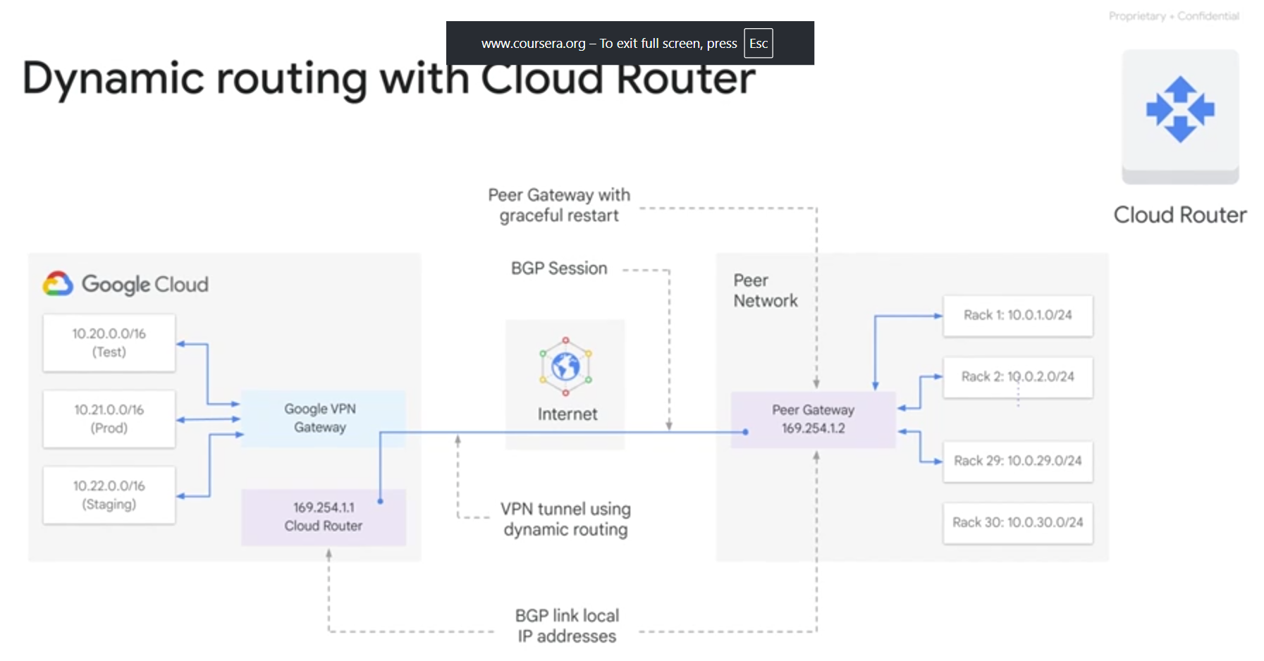

Cloud Interconnect and Peering Apr 16, 2026
This course content explains the different Cloud Interconnect and Peering services available to connect your infrastructure to Google's network.
Cloud Interconnect and Peering Services Overview
- Services include Direct Peering, Carrier Peering, Dedicated Interconnect, and Partner Interconnect.
- These services are categorized as Dedicated vs. Shared connections and Layer 2 vs. Layer 3 connections.
Connection Types and Characteristics
- Dedicated connections provide a direct link to Google's network, while shared connections connect through a partner.
- Layer 2 connections use VLANs for internal IP address connectivity; Layer 3 connections provide access to public Google services using public IPs.
Cloud VPN Integration
- Google Cloud VPN uses the public internet with encrypted traffic to access internal IP addresses.
- Cloud VPN complements Direct Peering and Carrier Peering by providing secure connectivity over the internet.
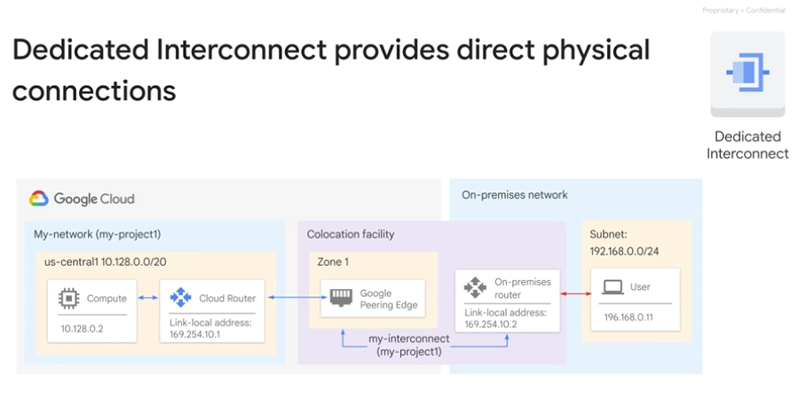
Cloud Interconnect Apr 16, 2026
This course content explains different options for connecting your on-premises network to Google Cloud Platform (GCP) and other cloud providers, focusing on capacity, requirements, and use cases.
Dedicated Interconnect
- Provides direct physical connections between your on-premises network and Google's network via a cross connect in a colocation facility.
- Supports high bandwidth (10 Gbps or 100 Gbps per link) and offers 99.9% or 99.99% uptime SLAs.
Partner Interconnect
- Connects your network to GCP through a supported service provider when you cannot reach a Dedicated Interconnect location.
- Offers bandwidth from 50 Mbps to 50 Gbps and similar uptime SLAs as Dedicated Interconnect.
Cross-Cloud Interconnect and Cloud VPN
- Cross-Cloud Interconnect enables dedicated high-bandwidth connections between Google Cloud and other cloud providers like AWS, Azure, Oracle, and Alibaba.
- Cloud VPN provides secure IPsec tunnels over the public internet with lower bandwidth (1.5 to 3 Gbps) and is suitable for lower cost or experimental setups.
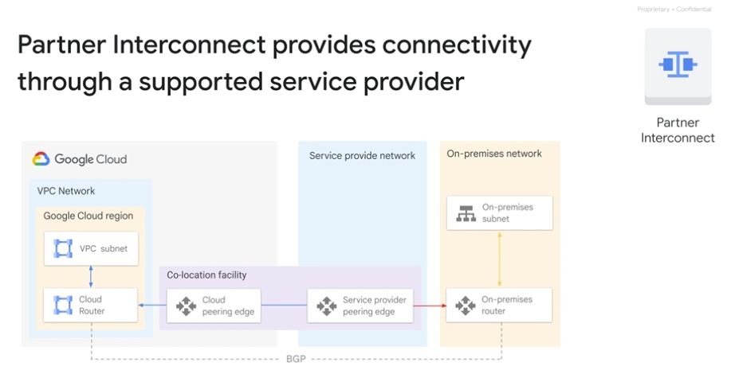
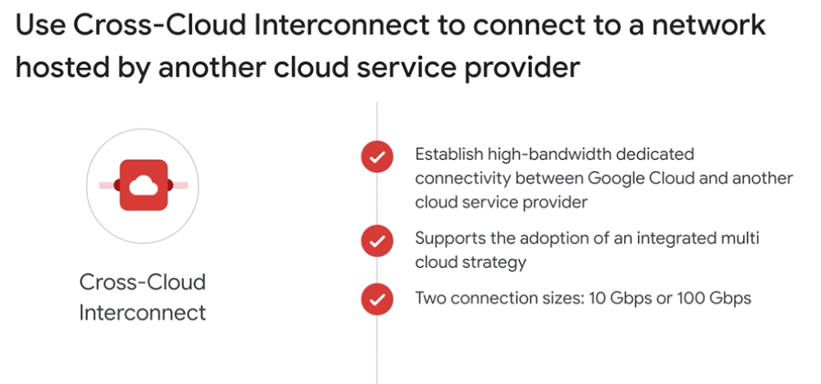
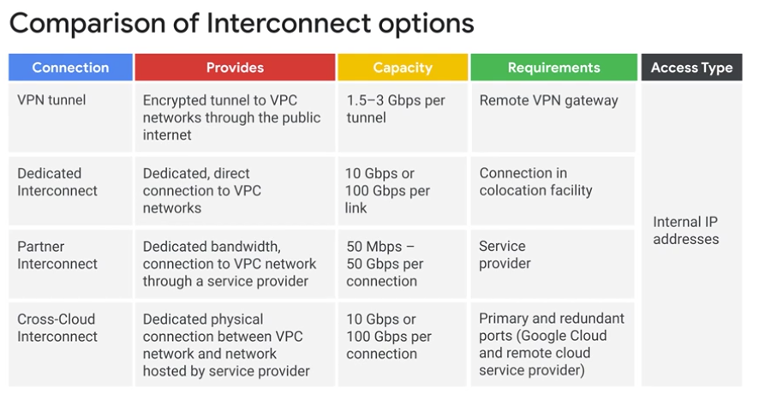
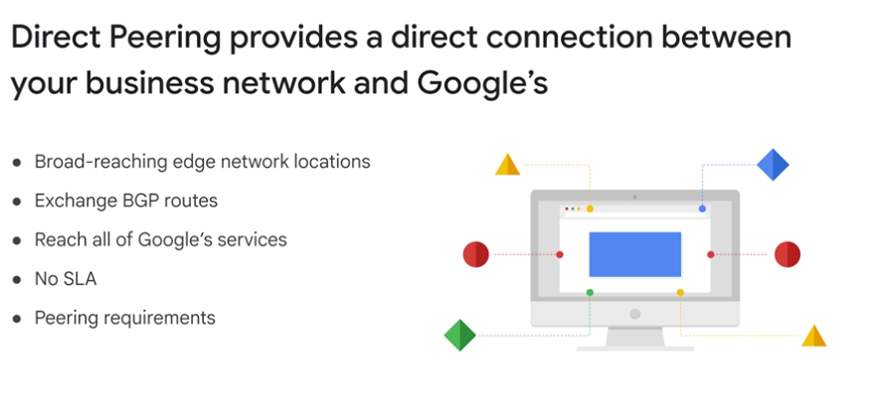
Peering Apr 16, 2026
This course content explains the Cloud Peering services offered by Google Cloud, focusing on direct peering and carrier peering options.
Cloud Peering Services Overview
- Direct peering allows businesses to establish a direct connection between their network and Google's network at Google's edge locations, enabling exchange of Internet traffic.
- Carrier peering is an alternative for those who cannot meet direct peering requirements, connecting through a service provider partner.
Direct Peering Details
- Uses BGP route exchange between Google and the peering entity.
- Provides access to all Google services and Google Cloud Platform products.
- Requires meeting specific peering requirements and having a connection at a Google Cloud Edge Point of Presence (PoP).
- Does not come with a service level agreement (SLA).
- Capacity is 10 Gbps per link.
Carrier Peering Details
- Connects via a carrier partner if direct peering requirements are not met or if the user is not near a Google PoP.
- Capacity and requirements vary depending on the service provider.
- Also does not have an SLA.
Comparison and Use Cases
- Both options provide public IP access to Google services.
- Direct peering is suitable for users near Google PoPs with the ability to meet requirements.
- Carrier peering is useful for users farther from Google PoPs or who cannot meet direct peering criteria.
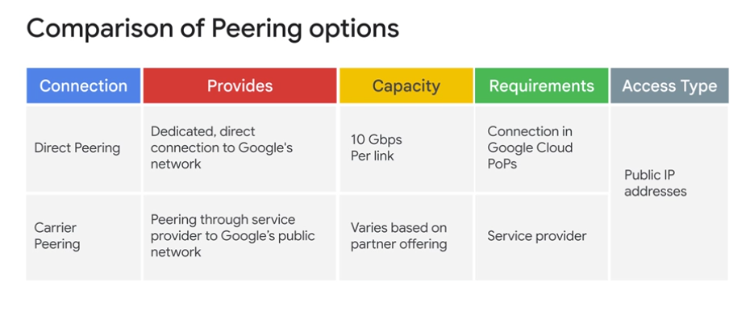
Choosing a connection Apr 16, 2026
This lecture helps you choose the best Google Cloud connectivity service for your hybrid infrastructure needs.
Connection Service Categories
- Services are divided into Dedicated vs. Shared connections and Layer 2 vs. Layer 3 connections.
- They can also be grouped into Interconnect services (direct access to VPC with SLA) and Peering services (access to Google public IPs without SLA).
Choosing Peering Services
- Use Peering if you need to extend your network for Workspace, YouTube, or Google Cloud APIs.
- Choose Direct Peering if you meet requirements; otherwise, use Carrier Peering.
Choosing Interconnect Services
- For extending your network to Google Cloud, start with colocation facilities.
- If you cannot meet Google at colocation, choose Cloud VPN for modest bandwidth and encryption or Partner Interconnect for higher needs.
- Within Partner Interconnect, select L2 for BGP peering or L3 if BGP is not needed.
- Dedicated Interconnect is suitable if you can meet colocation and have high bandwidth needs but consider Cloud VPN or Partner Interconnect if encryption or connection size is a concern.
Encryption and Additional Options
- Google supports VPN over Interconnect for Google-managed encryption.
- Choose Cloud VPN over Interconnect if you want Google-managed encryption on your connection.
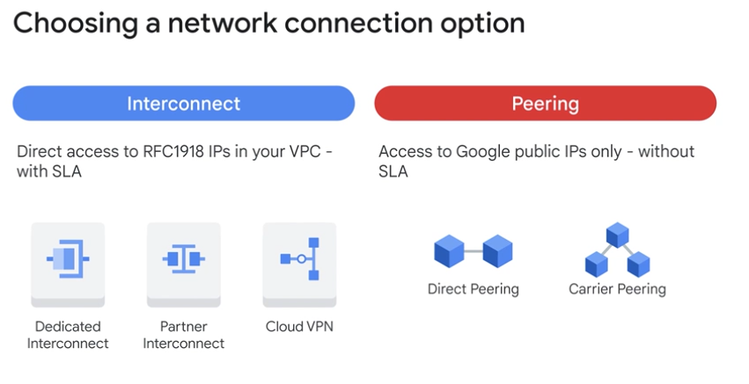
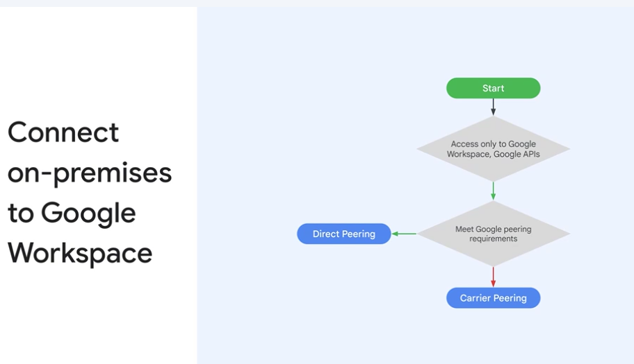
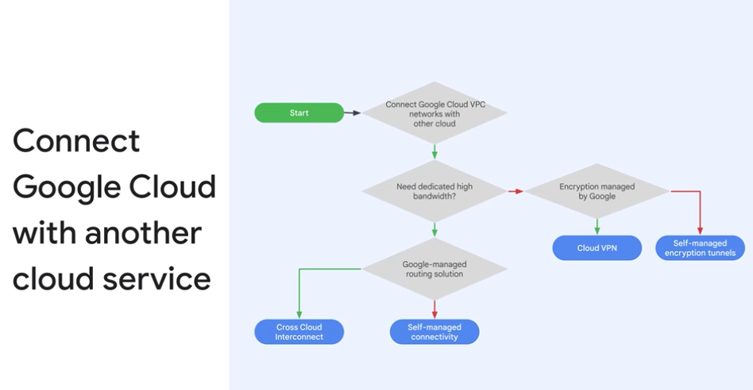
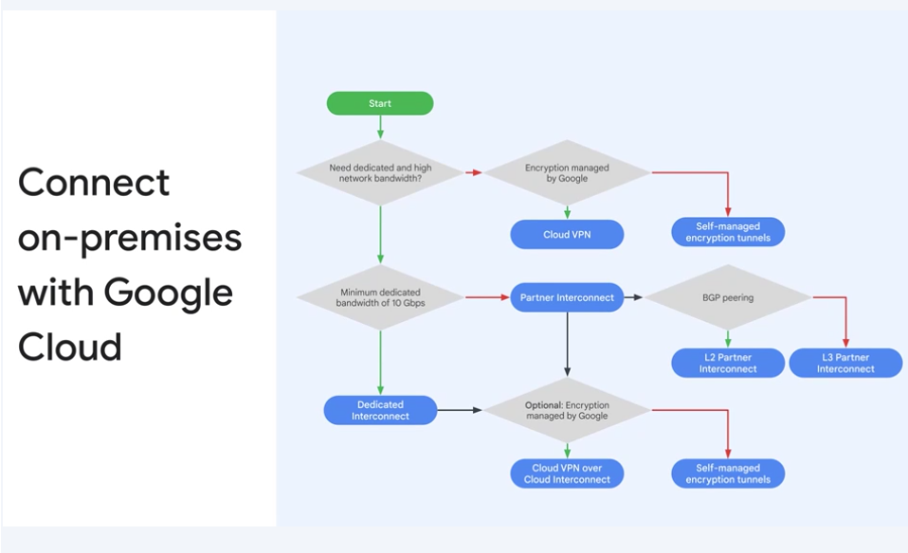

Shared VPC and VPC Peering Apr 16, 2026
This course item explains two methods for sharing Virtual Private Cloud (VPC) networks across Google Cloud Platform (GCP) projects to enable secure and efficient communication.
Shared VPC
- Allows multiple projects within the same GCP organization to share a common VPC network by designating one project as the host and others as service projects.
- Centralizes network administration, letting organization admins control network resources while delegating instance management to service project admins.
VPC Network Peering
- Enables private communication between VPC networks across projects, even in different organizations, by establishing peering connections.
- Each VPC network maintains its own firewall and routing policies, making this a decentralized approach to multi-project networking.
Comparison and Use Cases
- Shared VPC works only within the same organization and across projects, providing centralized control.
- VPC Network Peering supports communication between networks in different organizations or within the same project, offering decentralized control.
- Peering avoids the latency, security, and cost issues of using external IPs or VPNs for private communication.
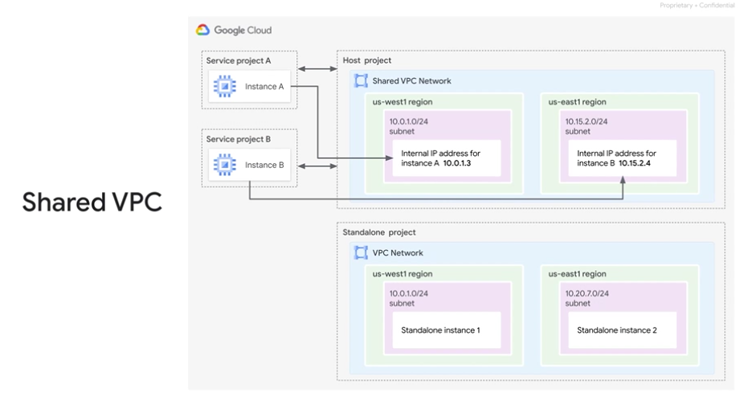
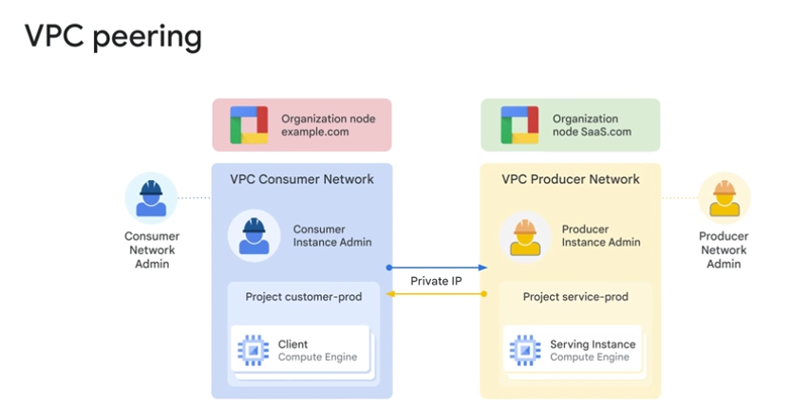
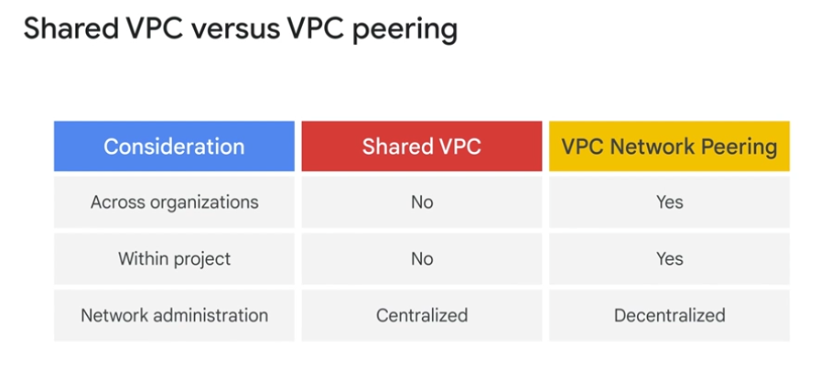
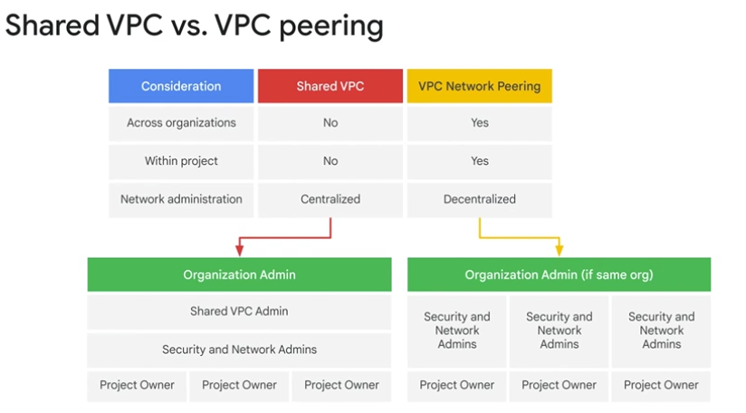

Module Overview Apr 16, 2026
This course module focuses on load balancing and autoscaling in Google Cloud Platform (GCP) to ensure high availability and scalability of applications.
Types of Load Balancers in GCP
- Global load balancers include HTTPS, SSL proxy, and TCP proxy, which use Google Frontends distributed globally and are suitable for globally distributed users and instances.
- Regional load balancers include external and internal HTTPS and TCP proxy, as well as internal and external TCP/UDP network load balancers, which distribute traffic within a single GCP region.
Load Balancing Features and Technologies
- Cloud Load Balancing is a fully distributed, software-defined managed service that does not require managing physical infrastructure.
- Internal load balancers use Andromeda (Google's network virtualization stack), and network load balancers use Maglev (a large distributed software system).
Autoscaling and Managed Instance Groups
- Managed instance groups work with load balancers to automatically scale resources up or down based on demand.
- Autoscaling configurations help maintain performance and availability while optimizing resource usage.
Practical Application and Course Structure
- The module includes labs to explore load balancing and autoscaling features hands-on.
- Guidance is provided to help determine the best GCP load balancer for specific needs.
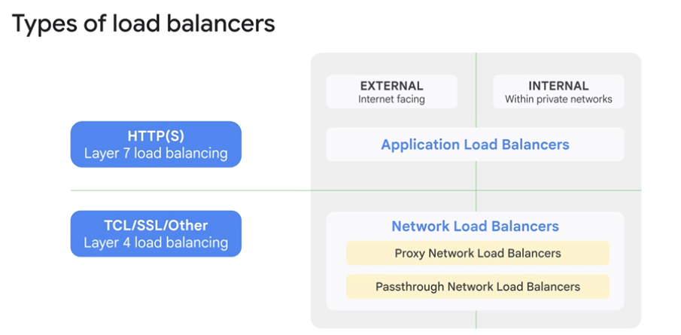
Managed instance groups Apr 16, 2026
This course content explains the concept and management of managed instance groups in Google Cloud.
Managed Instance Groups Overview
- A managed instance group is a collection of identical VM instances controlled as a single entity using an instance template.
- It supports rolling updates, automatic scaling, and integration with load balancing to distribute network traffic.
Instance Group Features and Benefits
- Automatically recreates instances that stop, crash, or are deleted, maintaining the same name and template.
- Can identify and replace unhealthy instances to ensure optimal performance.
- Regional managed instance groups are preferred for spreading load across multiple zones, providing fault tolerance.
Creating and Configuring Managed Instance Groups
- Creation starts with an instance template, followed by specifying the number of instances in the group.
- Configuration includes choosing the group type (stateless or stateful), naming, zone selection, instance template, autoscaling options, and health checks to manage traffic distribution.
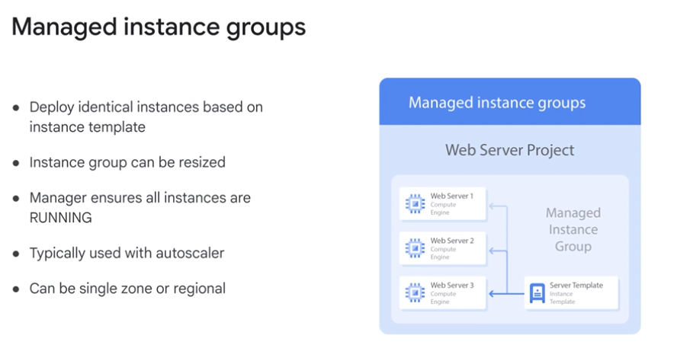
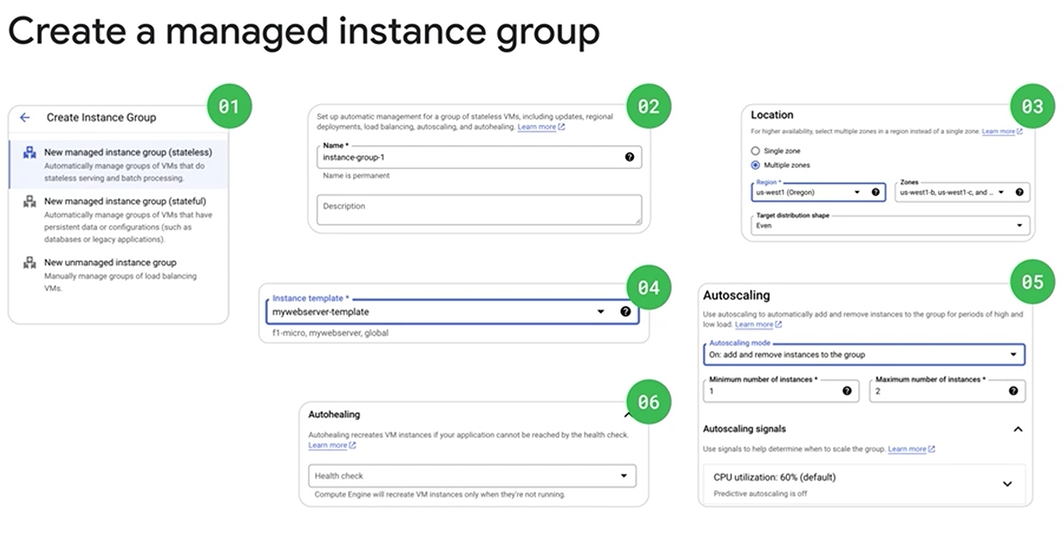
Autoscaling and health checks Apr 16, 2026
This lecture explains key features of managed instance groups in Google Cloud, focusing on autoscaling, health checks, and stateful IP address configuration.
Autoscaling in Managed Instance Groups
- Autoscaling automatically adjusts the number of instances based on load, helping applications handle traffic spikes and reduce costs during low demand.
- Autoscaling policies can be based on CPU utilization, load balancing capacity, monitoring metrics, queue workloads, or schedules.
Health Checks for Load Balancers
- Health checks monitor the status of instances by defining protocols, ports, and health criteria such as check intervals, timeouts, and thresholds.
- Instances are marked healthy or unhealthy based on these checks, ensuring traffic is routed only to healthy instances.
Stateful IP Address Configuration
- Stateful IP addresses preserve internal and external IPv4 addresses during autohealing, updates, or recreation of instances.
- This is useful for applications requiring static IPs, specific IP configurations, or seamless workload migration without network changes.
Overview of Application Load Balancing Apr 16, 2026
This course item explains the architecture and features of HTTP(S) load balancing in Google Cloud Platform (GCP), which operates at the application layer (Layer 7) of the OSI model.
HTTP(S) Load Balancing Overview
- Provides global load balancing for HTTP and HTTPS traffic across multiple backend instances and regions using a single anycast IP address.
- Supports IPv4 and IPv6 clients, scales automatically without pre-warming, and enables content-based routing via URL maps.
Load Balancer Architecture and Request Routing
- Incoming requests are directed by a global forwarding rule to a target HTTP proxy, which uses URL maps to route requests to appropriate backend services based on URL paths.
- Backend services route requests to instance groups based on capacity, zone, and instance health, with requests generally sent to the closest instance group.
Backend Services and Instance Group Configuration
- Backend services include health checks to ensure only healthy instances receive traffic, session affinity to keep client requests on the same instance, and timeout settings for request handling.
- Instance groups can be managed or unmanaged, with balancing modes based on CPU utilization or requests per second, and capacity scalers to control instance usage levels. Changes to backend services take several minutes to propagate.
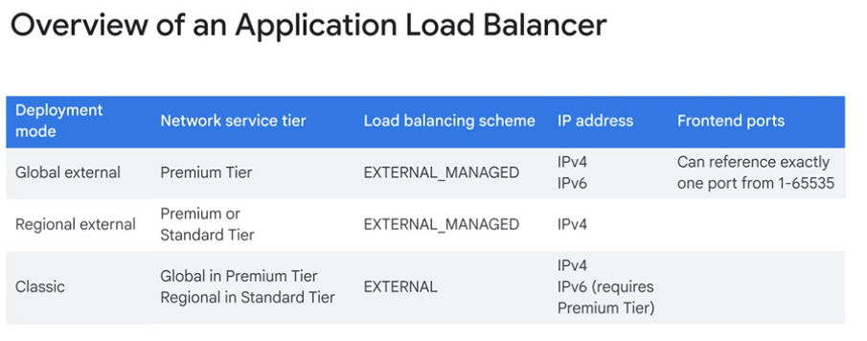

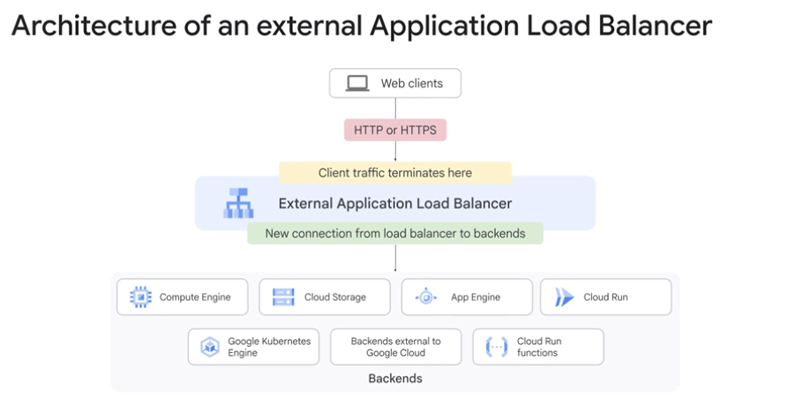
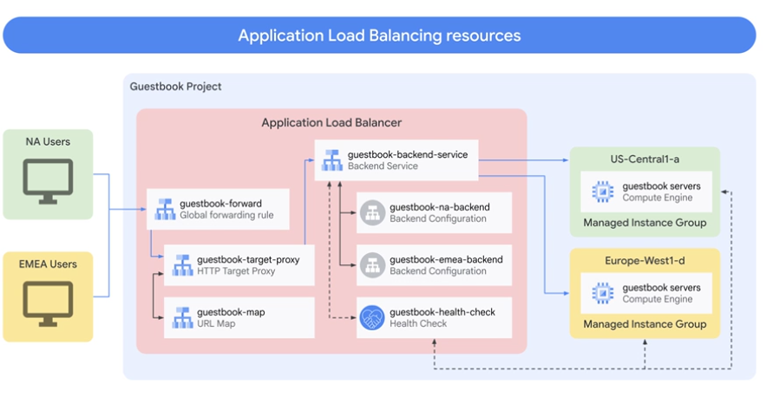

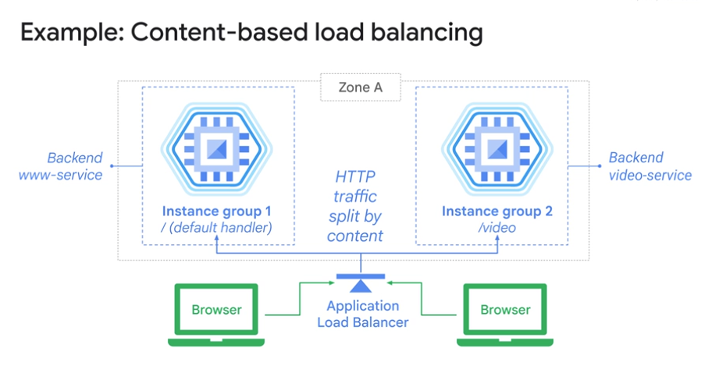

Application Load Balancing Apr 16, 2026
This course content explains the features and components of an HTTP(S) load balancer in Google Cloud.
HTTP(S) Load Balancer Basics
- Uses a target HTTPS proxy instead of HTTP proxy and requires at least one signed SSL certificate.
- Client SSL sessions terminate at the load balancer, which supports the QUIC transport protocol for faster connections and connection migration.
SSL Certificates and Backend Buckets
- Up to 15 SSL certificates can be configured on the target proxy, each represented by an SSL certificate resource.
- Backend buckets allow serving static content from Google Cloud Storage, with URL maps directing traffic to backend services or buckets based on URL paths.
Network Endpoint Groups (NEGs)
- NEGs specify groups of backend endpoints or services, useful for containerized deployments and granular traffic distribution.
- Types of NEGs include zonal (Compute Engine VMs), internet (external endpoints), hybrid connectivity (Traffic Director services outside Google Cloud), and serverless (Cloud Run, App Engine, Cloud Functions).
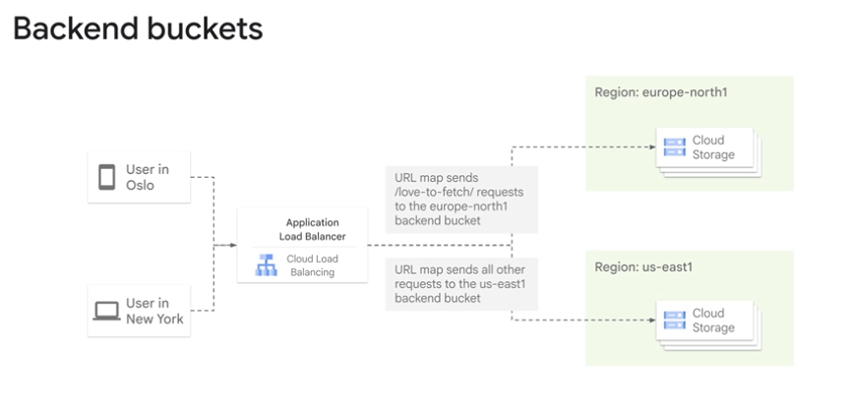
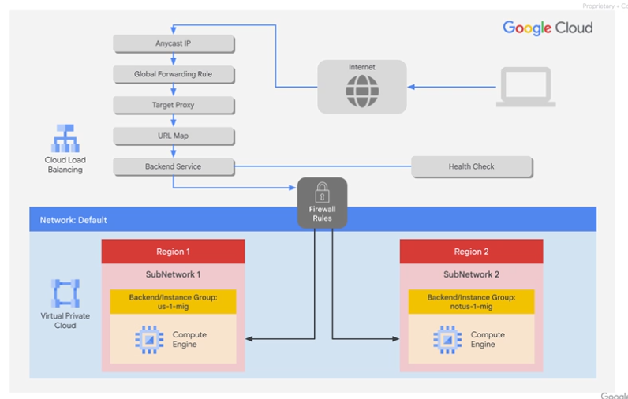

Configure an Application Load Balancer with Autoscaling
experimentLabschedule1 houruniversal_currency_altNo costshow_chartIntroductory
infoThis lab may incorporate AI tools to support your learning.

Overview
Application Load Balancing (HTTP/HTTPS) is implemented at the edge of Google's network in Google's points of presence (POP) around the world. User traffic directed to an Application Load Balancer (HTTP/HTTPS) enters the POP closest to the user and is then load-balanced over Google's global network to the closest backend that has sufficient available capacity.
In this lab, you configure an Application Load Balancer (HTTP) as shown in the diagram below. Then, you stress test the load balancer to demonstrate global load balancing and autoscaling.
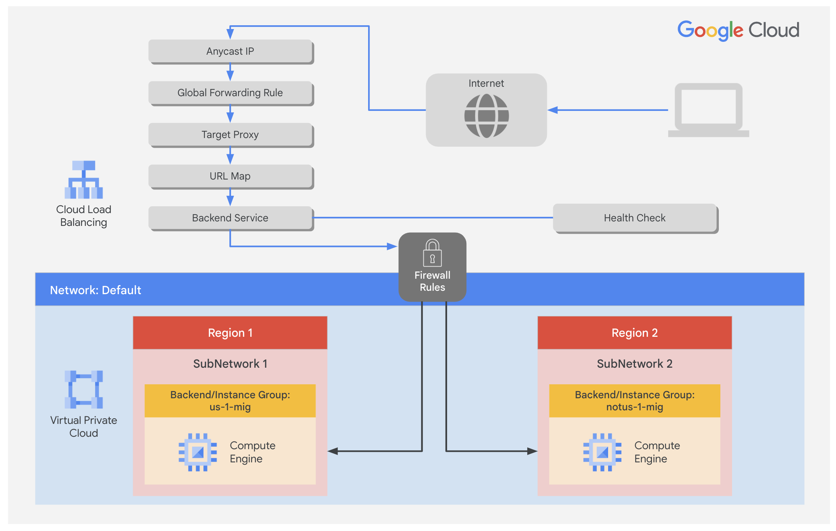

Objectives
In this lab, you learn how to perform the following tasks:
- Create a health check firewall rule
- Create a NAT configuration using Cloud Router
- Create a custom image for a web server
- Create an instance template based on the custom image
- Create two managed instance groups
- Configure an Application Load Balancer (HTTP) with IPv4 and IPv6
- Stress test an Application Load Balancer (HTTP)
For each lab, you get a new Google Cloud project and set of resources for a fixed time at no cost.
- Click the Start Lab button. If you need to pay for the lab, a pop-up opens for you to select your payment method. On the left is the Lab Details panel with the following:
  - The Open Google Cloud console button
  - Time remaining
  - The temporary credentials that you must use for this lab
  - Other information, if needed, to step through this lab
- Click Open Google Cloud console (or right-click and select Open Link in Incognito Window if you are running the Chrome browser).
The lab spins up resources, and then opens another tab that shows the Sign in page.
Tip: Arrange the tabs in separate windows, side-by-side.
- Note: If you see the Choose an account dialog, click Use Another Account.
- If necessary, copy the Username below and paste it into the Sign in dialog.
- "Username"
- Copied!
- You can also find the Username in the Lab Details panel.
- Click Next.
- Copy the Password below and paste it into the Welcome dialog.
- "Password"
- Copied!
- You can also find the Password in the Lab Details panel.
- Click Next.
- Important: You must use the credentials the lab provides you. Do not use your Google Cloud account credentials.
- Note: Using your own Google Cloud account for this lab may incur extra charges.
- Click through the subsequent pages:
  - Accept the terms and conditions.
  - Do not add recovery options or two-factor authentication (because this is a temporary account).
  - Do not sign up for free trials.
After a few moments, the Google Cloud console opens in this tab.
Note: To view a menu with a list of Google Cloud products and services, click the Navigation menu at the top-left, or type the service or product name in the Search field. 

Task 1. Configure a health check firewall rule
In this task, you configure a firewall rule to allow health check traffic to your instances.
Health checks determine which instances of a Application Load Balancer (HTTP) can receive new connections. The health check probes to your load-balanced instances come from addresses in the ranges 130.211.0.0/22 and 35.191.0.0/16. Your firewall rules must allow these connections.

Create the health check rule
Create a firewall rule to allow health checks.
- In the Google Cloud console, in the Navigation menu (), click VPC network > Firewall.
Notice the existing ICMP, internal, RDP, and SSH firewall rules.
Each Google Cloud project starts with the default network and these firewall rules.
- Click Create Firewall Rule.
- Specify the following, and leave the remaining settings as their defaults:
Property | Value (type value or select option as specified)
Name | fw-allow-health-checks
Network | default
Targets | Specified target tags
Target tags | allow-health-checks
Source filter | IPv4 ranges
Source IPv4 ranges | 130.211.0.0/22 and 35.191.0.0/16
Protocols and ports | Specified protocols and ports
Note: Make sure to include the /22 and /16 in the Source IP ranges.
- Select tcp and specify port 80.
- Click Create.
Click Check my progress to verify the objective.
Configure health check firewall rule

Task 2. Create a NAT configuration using Cloud Router
In this task, you create a Cloud Router instance and configure a Cloud NAT gateway to enable outbound internet connectivity for your VM instances.
The Google Cloud VM backend instances that you set up in Task 3 will not be configured with external IP addresses.
Instead, you will set up the Cloud NAT service to allow these VM instances to send outbound traffic only through the Cloud NAT, and receive inbound traffic through the load balancer.

Create the Cloud Router instance
- On the Google Cloud console title bar, type Network services in the Search field, then click Network services in the Network management tools section.
- On the Network service page, click Pin next to Network services.
- Click Cloud NAT.
- Click Get started to configure a NAT gateway.
- Specify the following, and leave the remaining settings as their defaults:
Property | Value (type value or select option as specified)
Gateway name | nat-config
Network | default
Region | Region 1
- Click Cloud Router, and select Create new router.
- For Name, type nat-router-us1.
- Click Create.
- In Create a NAT gateway, click Create.
Note: Wait until the NAT Gateway Status changes to Running before moving onto the next task.
Click Check my progress to verify the objective.
Create a NAT configuration using Cloud Router

Task 3. Create a custom image for a web server
In this task, you create a custom web server image for the backend of the load balancer.

Create a VM
- In the Google Cloud console, in the Navigation menu (), click Compute Engine > VM instances.
- Click Create Instance.
- Specify the following, and leave the remaining settings as their defaults:
Property | Value (type value or select option as specified)
Name | webserver
Region | Region 1
Zone | Zone 1
- Click OS and storage, and then click Change.
- Click Show Advanced Configuration.
- For Deletion rule, select Keep boot disk.
- Click Select.
- Click Networking.
  - For Network tags, type allow-health-checks.
  - For Network interfaces , click default.
  - For External IPv4 address dropdown, select None.
- Click Done.
- Click Create.

Customize the VM
- For webserver, click SSH to launch a terminal and connect.
- If prompted allow SSH-in-browser to connect to VMs, click Authorize.
- To install Apache2, run the following commands:
sudo apt-get update
sudo apt-get install -y apache2
Copied!
- To start the Apache server, run the following command:
sudo service apache2 start
Copied!
- To test the default page for the Apache2 server, run the following command:
curl localhost
Copied!
The default page for the Apache2 server should be displayed.

Set the Apache service to start at boot
The software installation was successful. However, when a new VM is created using this image, the freshly booted VM does not have the Apache web server running. Use the following command to set the Apache service to automatically start on boot. Then test it to make sure it works.
- In the webserver SSH terminal, set the service to start on boot:
sudo update-rc.d apache2 enable
Copied!
- In the Cloud console, select webserver, and then click More actions .
- Click Reset.
- In the confirmation dialog, click Reset.
Note: Reset will stop and reboot the machine. It keeps the same IPs and the same persistent boot disk, but memory is wiped. Therefore, if the Apache service is available after the reset, the update-rc command was successful.
- Check the server by connecting via SSH to the VM and entering the following command:
sudo service apache2 status
Copied!
Note: If you see the Connection via Cloud Identity-Aware Proxy Failed popup, click Retry.
- The result should show Started The Apache HTTP Server.

Prepare the disk to create a custom image
Verify that the boot disk will not be deleted when the instance is deleted.
- On the VM instances page, click webserver to view the VM instance details.
- For Storage > Boot disk, verify that When deleting instance is set to Keep disk.
- Return to the VM instances page, select webserver, and then click More actions () .
- Click Delete.
- In the confirmation dialog, click Delete.
- In the left pane, click Disks and verify that the webserver disk exists.

Create the custom image
- In the left pane, click Images.
- Click Create image.
- Specify the following, and leave the remaining settings as their defaults:
Property | Value (type value or select option as specified)
Name | mywebserver
Source | Disk
Source disk | webserver
- Click Create.
Note: You have created a custom image that multiple identical webservers can be started from. At this point, you could delete the webserver disk.
The next step is to use that image to define an instance template that can be used in the managed instance groups.
Click Check my progress to verify the objective.
Create a custom image for a web server

Task 4. Configure an instance template and create instance groups
In this task, you configure instance templates and create managed instance groups for your load-balanced web server.
A managed instance group uses an instance template to create a group of identical instances. Use these to create the backends of the HTTP load balancer.

Configure the instance template
An instance template is an API resource that you can use to create VM instances and managed instance groups. Instance templates define the machine type, boot disk image, subnet, labels, and other instance properties.
- In the Google Cloud console, in the Navigation menu (), click Compute Engine > Instance templates.
- Click Create Instance Template.
- For Name, type mywebserver-template.
- For Location, select Global.
- For Series, select E2.
- For Machine type > Shared-core, select e2-micro (2 vCPU, 1 core, 1 GB memory).
- For Boot disk, click Change.
- Click Custom images, for Source project for images make sure that qwiklabs project ID is selected.
- For Image, Select mywebserver.
- Click Select.
- Click Advanced options.
- Click Networking.
  - For Network tags, type allow-health-checks.
  - For Network interfaces , click default.
  - For External IPv4 IP dropdown, select None.
  - Click Done.
- Click Create.

Create the health check for managed instance groups
- On the Navigation menu, click Compute Engine > Health checks.
- Click Create health check.
- Specify the following, and leave the remaining settings as their defaults:
Property | Value (select option as specified)
Name | http-health-check
Protocol | TCP
Port | 80
- Click Create.
Managed instance group health checks proactively signal to delete and recreate instances that become unhealthy.

Create the managed instance groups
Create a managed instance group in Region 1 and one in Region 2.
- On the Navigation menu, click Compute Engine > Instance groups.
- Click Create Instance Group.
- Specify the following, and leave the remaining settings as their defaults:
Property | Value (type value or select option as specified)
Name | us-1-mig
Instance template | mywebserver-template
Location | Multiple zones
Region | Region 1
- For Autoscaling, enter Minimum number of instances 1 and Maximum number of instances 2.
- For Autoscaling signals, click on the CPU utilization.
- For Signal type, select HTTP load balancing utilization.
- Enter Target HTTP load balancing utilization to 80.
- Click Done.
- Click Initialization period and set to 60 seconds.
Note: Managed instance groups offer autoscaling capabilities that allow you to automatically add or remove instances from a managed instance group based on increases or decreases in load. Autoscaling helps your applications gracefully handle increases in traffic and reduces cost when the need for resources is lower. You just define the autoscaling policy, and the autoscaler performs automatic scaling based on the measured load.
- In Autohealing, for health check type http-health-check
- Select http-health-check (TCP)
- For Initial delay, type 60. This is how long the Instance Group waits after initializing the boot-up of a VM before it tries a health check. You don't want to wait 5 minutes for this during the lab, so you set it to 1 minute.
- Click Create.
- Click Confirm in the dialog window.
Note: Wait a few minutes for the Instance Group to be created before repeating the same procedure for notus-1-mig in Region 2 Click Refresh until the Status changes to Transforming.
Note: If a warning window appears, or you see a red exclamation mark to the left of the instance group after creation stating There is no backend service attached to the instance group. Ignore this; you will configure the load balancer with a backend service in the next section of the lab.
- Click Create Instance Group.
- Specify the following, and leave the remaining settings as their defaults:
Property | Value (type value or select option as specified)
Name | notus-1-mig
Instance template | mywebserver-template
Location | Multiple zones
Region | Region 2
Autoscaling > Minimum number of instances | 1
Autoscaling > Maximum number of instances | 2
Autoscaling signals > Signal Type | HTTP load balancing utilization
Target HTTP load balancing utilization | 80
initialization period | 60
- For Health check, select http-health-check (TCP).
- For Initial delay, type 60.
- Click Create.
- Click Confirm in the dialog window.
Click Check my progress to verify the objective.
Configure an instance template and create instance groups

Verify the backends
Verify that VM instances are being created in both regions.
- On the Navigation menu, click Compute Engine > VM instances.
Notice the instances that start with us-1-mig and notus-1-mig. These instances are part of the managed instance groups.

Task 5. Configure the Application Load Balancer (HTTP)
In this task, you configure the Application Load Balancer (HTTP) to balance traffic between the two backends (us-1-mig in Region 1 and notus-1-mig in Region 2) as illustrated in the network diagram:
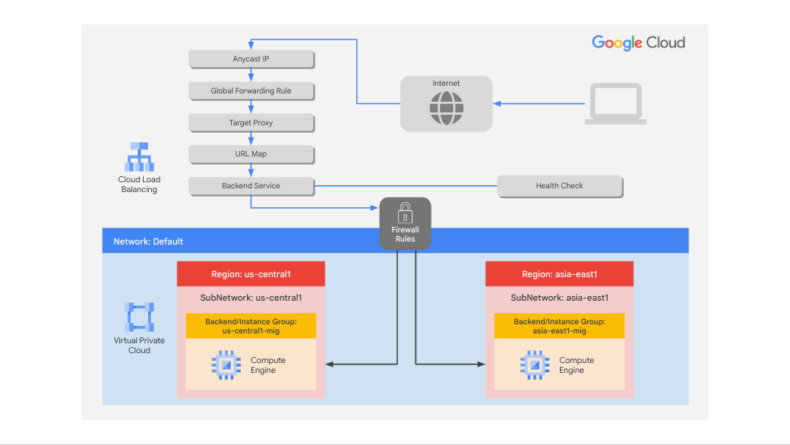

Start the configuration
- On the Navigation menu, click Network Services > Load balancing.
- Click Create Load Balancer.
- For Type of load balancer, select Application Load Balancer (HTTP/HTTPS), click Next.
- For Public facing or internal, select Public facing (external), click Next.
- For Global or single region deployment, select Best for global workloads, click Next.
- For Load balancer generation, select Global external Application Load Balancer, click Next.
- For Create load balance, click Configure.
- For Load Balancer Name, type http-lb.

Configure the frontend
The host and path rules determine how your traffic will be directed. For example, you could direct video traffic to one backend and direct static traffic to another backend. However, you are not configuring the host and path rules in this lab.
- Click Frontend configuration.
- Specify the following, and leave the remaining settings as their defaults:
Property | Value (type value or select option as specified)
Protocol | HTTP
IP version | IPv4
IP address | Ephemeral
Port | 80
- Click Done.
- Click Add Frontend IP and Port.
- Specify the following, and leave the remaining settings as their defaults:
Property | Value (type value or select option as specified)
Protocol | HTTP
IP version | IPv6
IP address | Auto-allocate
Port | 80
- Click Done.
Application Load Balancing (HTTP/HTTPS) supports both IPv4 and IPv6 addresses for client traffic. Client IPv6 requests are terminated at the global load balancing layer and then proxied over IPv4 to your backends.

Configure the backend
Backend services direct incoming traffic to one or more attached backends. Each backend is composed of an instance group and additional serving capacity metadata.
- Click Backend Configuration.
- Click Backend services & backend buckets > Create a Backend Service.
- Specify the following, and leave the remaining settings as their defaults:
Property | Value (select option as specified)
Name | http-backend
Backend type | Instance group
Instance group | us-1-mig
Port numbers | 80
Balancing mode | Rate
Maximum RPS | 50
Capacity | 100
Note: This configuration means that the load balancer attempts to keep each instance of us-1-mig at or below 50 requests per second (RPS).
- Click Done.
- Click Add Backend.
- Specify the following, and leave the remaining settings as their defaults:
Property | Value (select option as specified)
Instance group | notus-1-mig
Port numbers | 80
Balancing mode | Utilization
Maximum backend utilization | 80
Capacity | 100
Note: This configuration means that the load balancer attempts to keep each instance of notus-1-mig at or below 80% CPU utilization.
- Click Done.
- For Health Check, select http-health-check.
- Click check for the Enable logging checkbox.
- Specify Sample rate as 1.
- Click Create.
- Click OK.

Review and create the HTTP load balancer
- Click Review and finalize.
- Review the Backend services and Frontend.
- Click Create. Wait for the load balancer to be created.
- Click on the name of the load balancer (http-lb).
- Note the IPv4 and IPv6 addresses of the load balancer for the next task. They will be referred to as [LB_IP_v4] and [LB_IP_v6], respectively.
Note: The IPv6 address is the one in hexadecimal format.
Click Check my progress to verify the objective.
Configure the Application Load Balancer (HTTP)

Task 6. Stress test the Application Load Balancer (HTTP)
In this task, you stress test your Application Load Balancer (HTTP) to verify that traffic is forwarded to the backend service.
The Application Load Balancer (HTTP) should forward traffic to the region that is closest to you.
True
False

Access the Application Load Balancer (HTTP)
- In the Google Cloud console title bar, click Activate Cloud Shell ().
- If prompted, click Continue.
- To check the status of the load balancer, run the following command, replace [LB_IP_v4] with the IPv4 address of the load balancer:
LB_IP=[LB_IP_v4]
while [ -z "$RESULT" ] ;
do
echo "Waiting for Load Balancer";
sleep 5;
RESULT=$(curl -m1 -s $LB_IP | grep Apache);
done
Copied!
Note: Once the load balancer is ready, the command will exit.
- Open a new tab in your browser and navigate to http://[LB_IP_v4]. Make sure to replace [LB_IP_v4] with the IPv4 address of the load balancer.
Note: If you get a pop-up as EXTERNAL_IP doesn’t support a secure connection click Continue to site

Stress test the Application Load Balancer (HTTP)
Create a new VM to simulate a load on the Application Load Balancer (HTTP). Then determine whether traffic is balanced across both backends when the load is high.
- In the Cloud console, in the Navigation menu (), click Compute Engine > VM instances.
- Click Create instance.
- Specify the following, and leave the remaining settings as their defaults:
Property | Value (type value or select option as specified)
Name | stress-test
Region | A region different but closer to Region 1
Zone | A zone from the region
- For Series, select E2.
- For Machine type, select e2-micro (2 vCPU, 1 core, 1 GB memory).
Note: Because a region in US is closer to Region 1 than to notus-1, traffic should be forwarded only to us-1-mig (unless the load is too high).
- Click OS and storage, and then click Change.
- Click Custom Images.
- Click Custom Images, then for Source project for images make sure that qwiklabs project ID is selected.
- For Image, select mywebserver.
- Click Select.
- Click Create.
- Wait for the stress-test instance to be created.
- For stress-test, click SSH to launch a terminal and connect.
- If prompted allow SSH-in-browser to connect to VMs, click Authorize.
- To create an environment variable for your load balancer IP address, run the following command:
export LB_IP=<Enter your [LB_IP_v4] here>
Copied!
- Verify it with echo:
echo $LB_IP
Copied!
- To place a load on the load balancer, run the following command:
ab -n 500000 -c 1000 http://$LB_IP/
Copied!
Click Check my progress to verify the objective.
Stress test the Application Load Balancer (HTTP)
- In the Cloud console, in the Navigation menu (), click Network Services > Load balancing.
- Click http-lb.
- Click Monitoring.
- Monitor the Frontend Location (Total inbound traffic) between North America and the two backends for a couple of minutes.
Note: At first, traffic should just be directed to us-1-mig, but as the RPS increases, traffic is also directed to notus-1-mig. This demonstrates that by default traffic is forwarded to the closest backend, but if the load is very high, traffic can be distributed across the backends.
- In the Cloud console, in the Navigation menu (), click Compute Engine > Instance groups.
- Click on us-1-mig to open the instance group page.
- Click Monitoring to monitor the number of instances and LB capacity.
- Repeat the same for the notus-1-mig instance group.
Note: Depending on the load, you might see the backends scale to accommodate the load.

Task 7. Review
In this lab, you configured an Application Load Balancer (HTTP) with backends in Region 1 and Region 2. Then you stress-tested the Application Load Balancer with a VM to demonstrate global load balancing and autoscaling.

End your lab
When you have completed your lab, click End Lab. Google Skills removes the resources you’ve used and cleans the account for you.
You will be given an opportunity to rate the lab experience. Select the applicable number of stars, type a comment, and then click Submit.
The number of stars indicates the following:
- 1 star = Very dissatisfied
- 2 stars = Dissatisfied
- 3 stars = Neutral
- 4 stars = Satisfied
- 5 stars = Very satisfied
You can close the dialog box if you don't want to provide feedback.
For feedback, suggestions, or corrections, please use the Support tab.
Copyright 2026 Google LLC All rights reserved. Google and the Google logo are trademarks of Google LLC. All other company and product names may be trademarks of the respective companies with which they are associated.
Cloud CDN Apr 17, 2026
This course item explains how Google Cloud's Cloud CDN (Content Delivery Network) works to improve content delivery by caching content closer to users.
Cloud CDN Overview
- Cloud CDN uses Google's globally distributed edge cache sites to store HTTP(S) load-balanced content near users, with over 90 cache locations worldwide.
- It speeds up content delivery and reduces backend serving costs by caching content at the network edge.
Cloud CDN Response Flow
- When a user requests content, the nearest cache site checks if it has the content (cache hit) or needs to fetch it (cache miss).
- On a cache miss, the request is forwarded to the HTTP(S) load balancer, which routes it to the appropriate backend (e.g., VM instance groups or Cloud Storage).
- Cacheable content is stored at the edge for future requests, reducing latency and backend load.
Cache Control and Modes
- Cloud CDN logs each request with cache hit or miss status for monitoring.
- Cache modes control how content is cached:
  - USE_ORIGIN_HEADERS respects cache directives from the origin.
  - CACHE_ALL_STATIC caches static content unless explicitly prohibited.
  - FORCE_CACHE_ALL caches all responses regardless of origin directives, but private or dynamic content should be excluded.
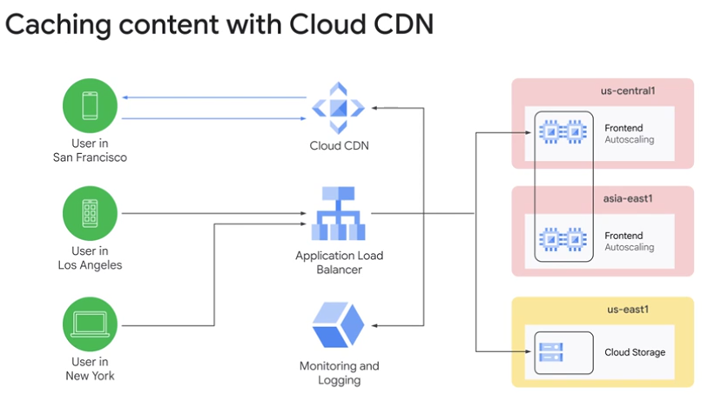

Network load balancing Apr 17, 2026
The content explains the concept and architecture of network load balancing in Google Cloud, focusing on its regional scope and operational details.
Network Load Balancing Overview
- It is a regional, non-proxied load balancing service that balances traffic only among VM instances within the same region.
- It uses forwarding rules to distribute traffic based on IP protocol data such as address, port, and protocol type, supporting UDP, TCP, and SSL traffic on certain ports.
Types of Network Load Balancers
- New network load balancers use regional back-end services that define load balancer behavior and support advanced features like non-legacy health checks, autoscaling, connection draining, and failover policies.
- Legacy network load balancers use target pools, which are groups of instances receiving traffic based on forwarding rules and a hash of source and destination IP and port.
Target Pools and Limitations
- Target pools can only handle TCP and UDP traffic, with a limit of 50 target pools per project and one health check per target pool.
- All instances in a target pool must reside in the same region, matching the regional limitation of the network load balancer.
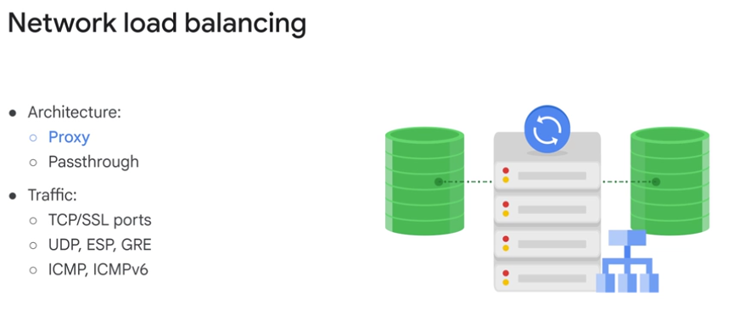
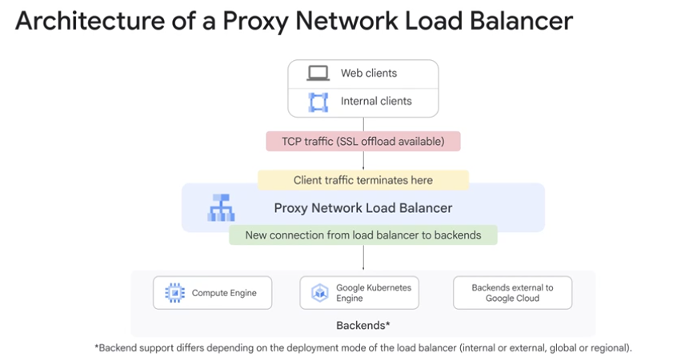
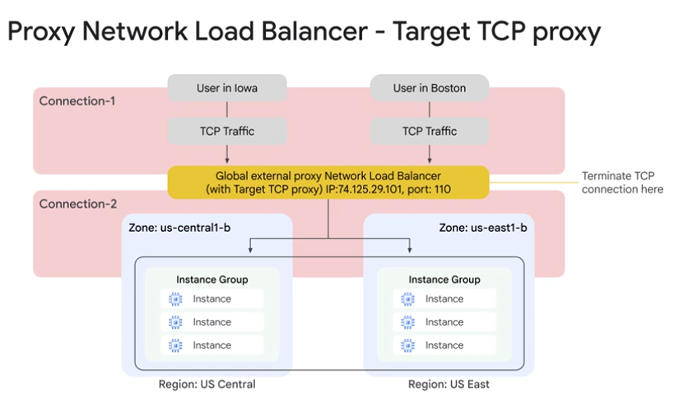
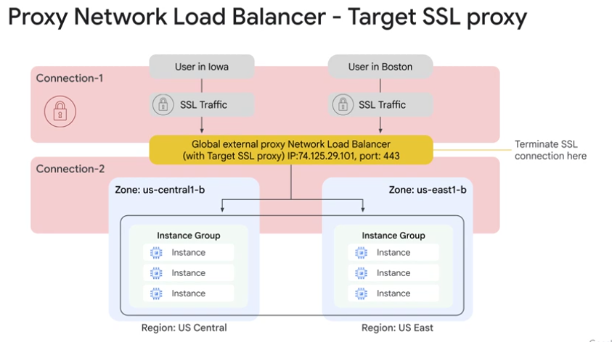
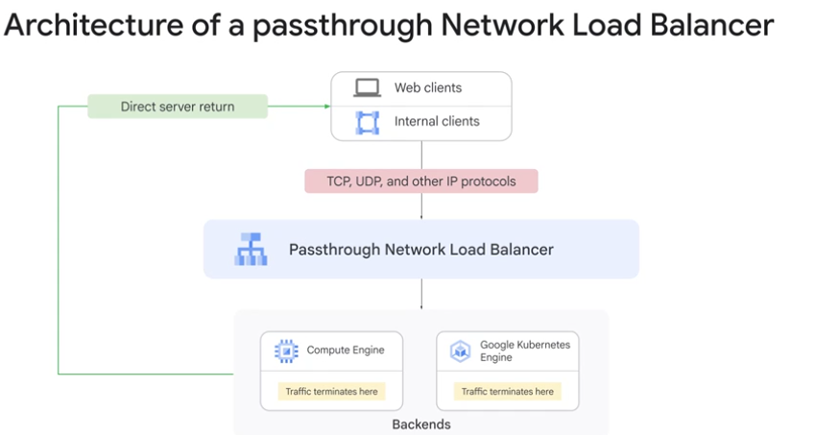
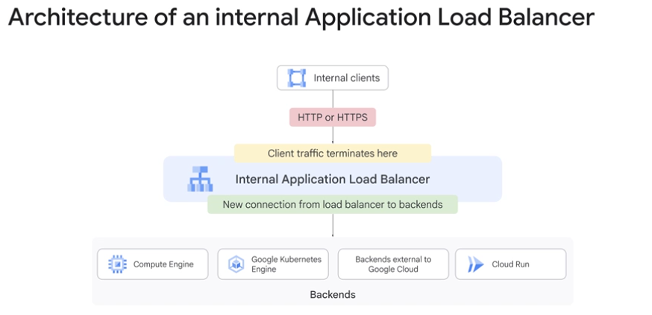
Internal load balancing Apr 17, 2026
This lecture explains the concept and benefits of internal load balancing in Google Cloud, focusing on TCP/UDP and HTTPS internal load balancers.
Internal TCP/UDP Load Balancing
- It is a regional private load balancing service for TCP and UDP traffic, accessible only within the same region via internal IP addresses.
- It uses a software-defined, fully distributed approach built on Google's Andromeda network virtualization stack, delivering traffic directly from client to back-end instances without proxying.
Internal HTTPS Load Balancing
- This is a proxy-based regional layer 7 load balancer supporting HTTP, HTTPS, and HTTP/2 protocols.
- It is managed using the open-source Envoy proxy, allowing rich traffic control and automatic scaling of proxies based on traffic needs.
Use Case: Three-Tier Web Services
- External HTTPS load balancers provide global access to users, with back ends in multiple regions.
- Internal load balancers serve as the application/internal tier within each region, keeping the application and database tiers private and not exposed externally.
- This architecture enhances security and simplifies network pricing by isolating internal tiers from public access.
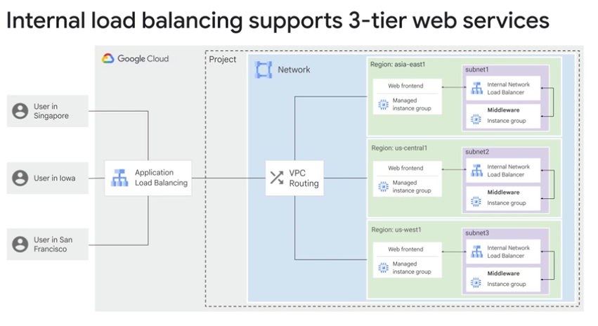

Lab Review: Configure an Internal Load Balancer Apr 17, 2026
This lecture focuses on configuring managed instance groups and setting up an internal load balancer in Google Cloud Platform (GCP) to enable scalable and balanced traffic distribution within a private network.
Managed Instance Groups and Firewall Rules
- Created two managed instance groups in different subnets within the US central one region.
- Configured firewall rules to allow HTTP traffic and TCP traffic from GCP health checkers, applying network tags for targeted access.
Instance Templates and Groups Setup
- Created instance templates with startup scripts hosted in a Cloud Storage bucket to initialize instances.
- Deployed managed instance groups using these templates, set autoscaling policies based on CPU usage, and assigned them to specific zones and subnets.
Internal Load Balancer Configuration and Testing
- Created an internal TCP load balancer with backend services linked to the two instance groups.
- Set up a health check for backend instances and assigned a static internal IP for the load balancer frontend.
- Verified load balancing by curling the load balancer IP from a utility VM, observing traffic distribution across backend instances.
Choosing a load balancer Apr 17, 2026
This course item explains how to choose the appropriate Google Cloud load balancer based on your application's needs and traffic types.
Load Balancer Types and IPv6 Support
- Only HTTP(S), SSL proxy, and TCP proxy load balancers support IPv6 clients by terminating IPv6 connections and proxying requests to IPv4 backends.
- This allows backend instances to appear as IPv6 applications to IPv6 clients, enabling seamless handling of both IPv4 and IPv6 traffic.
Choosing the Right Load Balancer
- Use an Application Load Balancer for flexible HTTP(S) application features.
- Use a proxy Network Load Balancer for TLS offload, TCP proxy, or multi-region backend support.
- Use a passthrough Network Load Balancer to preserve client IPs, avoid proxy overhead, and support protocols like UDP, ESP, and ICMP.
Additional Considerations
- Decide if your application is external (internet-facing) or internal, and whether backends are global or regional.
- The load-balancing scheme (MANAGED or not) indicates if the load balancer is a managed service routing requests via Google Front Ends or Envoy proxies.
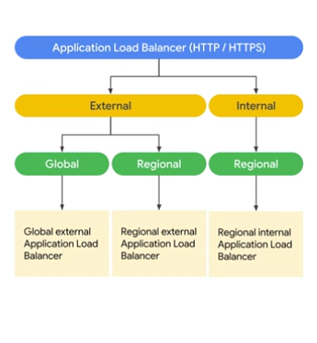
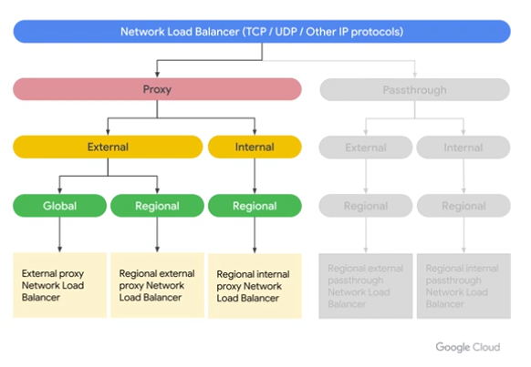
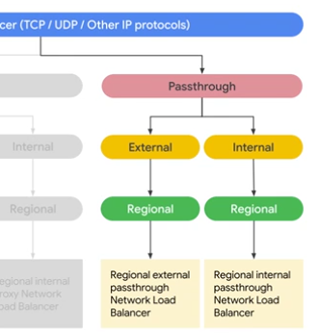

At its core, Envoy is a high-performance, open-source edge and service proxy designed for cloud-native applications. Originally built by Lyft, it has become the gold-standard "data plane" for modern Service Mesh architectures (like Istio).
If you think of a web server (like Nginx) as a front door to a building, Envoy is more like a sophisticated network of pneumatic tubes and security checkpoints inside a massive warehouse, ensuring every package (data packet) gets to the right desk as fast as possible.

Why use Envoy?
In the old days of monolithic apps, everything lived in one place. In a microservices world, services are constantly talking to each other over an unreliable network. Envoy solves the "networking is hard" problem by sitting alongside your application and handling the mess.

1. The Sidecar Pattern
Envoy usually runs as a sidecar. This means every microservice has its own "bodyguard" Envoy proxy. The application doesn't talk to the network directly; it talks to Envoy, and Envoy talks to the rest of the world.

2. L7 (Application Layer) Awareness
While traditional load balancers often only see IP addresses and ports (Layer 4), Envoy understands HTTP, gRPC, and MongoDB protocols (Layer 7). It can look at a URL and say, "This request has a /user header, send it to the User Service," or "This request looks like an attack, block it."

3. Resilience and "Self-Healing"
Envoy is obsessed with keeping the network alive. It includes:
- Retries: If a service doesn't answer, Envoy automatically tries again.
- Circuit Breaking: If a service is failing repeatedly, Envoy stops sending traffic to it so it can recover, rather than overwhelming it.
- Timeouts: It prevents a slow service from hanging up the entire system.

4. Observability
Because all traffic passes through Envoy, it acts as a massive data collector. It provides detailed metrics (success rates, latency, volume) without you having to write a single line of monitoring code in your actual application.

Envoy vs. Nginx vs. HAProxy
Feature | Nginx / HAProxy | Envoy
Primary Use | Static content / Edge Load Balancing | Microservices / Service Mesh
Configuration | Static files (requires reload) | Dynamic API (updates without restart)
Protocols | HTTP, TCP | HTTP/2, gRPC, Thrift, MongoDB, WASM
Architecture | Process-based | Thread-per-connection (L7 optimized)

Use Case Example
Imagine you are deploying a new version of your "Checkout" service. You can tell Envoy to send 99% of traffic to the old version and 1% to the new version (Canary Deployment). Envoy handles the split, monitors the 1% for errors, and can automatically roll back if it sees issues—all without your application knowing anything happened.
Are you looking to implement Envoy as a standalone load balancer, or are you exploring its use within a service mesh like Istio?

Quiz: Load Balancing and Autoscaling Answers
1. Which of the following is not a Google Cloud load balancing service?
- Answer: Global hardware-defined Load Balancer
- Reasoning: Google Cloud uses a software-defined networking (SDN) stack called Andromeda to handle load balancing. There is no "hardware-defined" service offered to users, as the entire infrastructure is virtualized.
2. Which load balancer is recommended for HTTP(S) traffic?
- Answer: Global external Application Load Balancer
- Reasoning: Application Load Balancers (ALBs) operate at Layer 7 (the Application layer), making them the correct choice for HTTP and HTTPS traffic. Regional versions exist, but the Global external ALB is the standard recommendation for internet-facing web traffic.
3. Which of the following are applicable autoscaling policies for managed instance groups? (Select all that apply)
- Answers: * CPU utilization
  - Load balancing capacity
  - Monitoring metrics
  - Queue-based workload (e.g., Pub/Sub)
- Reasoning: Managed Instance Groups (MIGs) are highly flexible. You can scale based on standard hardware metrics like CPU, the amount of traffic hitting your Load Balancer, custom Cloud Monitoring metrics, or the length of a message queue.

Additional Relevant Sections for Your Course
Since you are moving into Scaling and Automation, adding these technical deep-dives will help you master production environments:

1. Self-Healing & Health Checks
It's not just about scaling up; it's about staying up.
- Liveness vs. Readiness Probes: Understanding the difference between a VM that is "running" and a VM that is actually "ready" to handle web requests.
- Auto-healing Policies: How to configure a MIG to automatically recreate an instance if its health check fails.

2. Infrastructure as Code (IaC) for Scaling
Scaling manually is a security and operational risk.
- Terraform for MIGs: Using code to define your instance templates and autoscaling policies.
- Deployment Manager: Google Cloud's native tool for automating the rollout of load balancers and network configurations.

3. Traffic Management & Blue/Green Deployments
Load balancers do more than just distribute weight.
- URL Maps: Routing traffic to different backend services based on the path (e.g., example.com/api goes to Service A, while example.com/images goes to a Cloud Storage bucket).
- Weighted Load Balancing: Safely testing new code by sending only 5% of traffic to a new "Green" instance group while keeping 95% on the stable "Blue" group.
Module Review Apr 17, 2026
This course module focuses on load balancing and autoscaling in Google Cloud Platform (GCP) to build scalable and resilient infrastructure.
Types of Load Balancers
- Various load balancers available in GCP are covered, including internal and external options.
- Criteria for choosing the appropriate load balancer are discussed, supported by a flowchart and summary table.
Managed Instance Groups and Autoscaling
- Managed instance groups enable automatic management of VM instances.
- Autoscaling adjusts the number of instances based on demand to maintain performance and cost efficiency.
Practical Application and Best Practices
- Hands-on labs allow applying concepts of load balancing and autoscaling.
- Combining internal and external load balancers can support complex architectures like three-tier web services.
Module Overview Apr 17, 2026
This course item introduces the concept of automating the deployment of Google Cloud infrastructure using Terraform.
Automation Challenges and Terraform Benefits
- Writing code to call the Cloud API directly can be complex and hard to maintain, especially when infrastructure definitions are spread across many code locations.
- Terraform provides a structured, template-based approach that abstracts Cloud API calls, making infrastructure definitions easier to read, understand, and maintain.
Using Terraform and Google Cloud Marketplace
- Terraform allows you to define infrastructure components like VPC networks, firewall rules, and VM instances in configuration files.
- The course module includes hands-on labs where you will use Terraform to deploy these infrastructure elements and also learn to launch solutions from Google Cloud Marketplace.
Terraform Apr 17, 2026
This course item introduces Terraform as a tool for infrastructure as code (IaC) on Google Cloud, explaining its purpose, benefits, and basic usage.
Infrastructure as Code (IaC) Overview
- IaC enables quick provisioning and removal of infrastructure on demand, automating deployment and managing complexity through code.
- It allows replication of environments like development and production, improving flexibility and consistency.
Terraform and Google Cloud Integration
- Terraform is an open-source IaC tool that uses declarative configuration files to provision Google Cloud resources such as virtual machines, storage, and networking.
- Google Cloud supports Terraform along with other IaC tools like Chef, Puppet, Ansible, and Packer, but this course focuses on Terraform.
Terraform Configuration and Workflow
- Terraform configurations describe resources using HashiCorp Configuration Language (HCL) with blocks, arguments, and expressions.
- The workflow includes initializing the configuration with terraform init, planning changes with terraform plan, and applying them with terraform apply to create or modify infrastructure as specified.
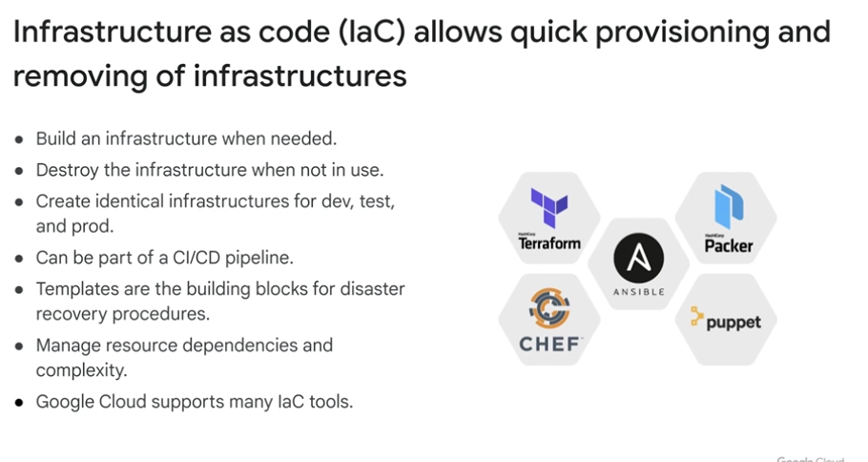

Lab Review: Automating the Deployment of Infrastructure Using Terraform Apr 20, 2026
This lecture focuses on automating the deployment of Google Cloud Platform (GCP) infrastructure using Terraform, emphasizing modular and incremental configuration management.
Terraform Setup and Initialization
- Terraform is integrated into GCP Cloud Shell, allowing easy version verification and initialization with the Google provider.
- A folder and code editor are set up in Cloud Shell to manage Terraform configuration files interactively.
Network and Firewall Configuration
- A Terraform resource is created for a Google Compute Network with auto-created subnetworks.
- A firewall rule resource is defined to allow HTTP, SSH, RDP, and ICMP traffic, with dependencies ensuring the network is created first.
Instance Module Creation and Deployment
- A reusable Terraform module for VM instances is created with input variables for name, zone, machine type, and subnetwork.
- The module is invoked in the main configuration to create multiple VM instances, with Terraform commands used to format, initialize, plan, and apply the infrastructure changes.
- The deployment is verified in the GCP console, confirming the network, firewall rules, and VM instances are correctly created and functional, including successful ping tests between instances.
Google Cloud Marketplace Apr 20, 2026
Google Cloud Marketplace enables quick deployment of functional software packages that run on Google Cloud.
Key Features of Google Cloud Marketplace
- Offers production-grade solutions from third-party vendors with deployment configurations based on Terraform.
- Solutions are billed together with your Google Cloud project services.
Deployment and Licensing
- Supports bring-your-own-license options if you already have a license for a third-party service.
- Allows scaling of deployments as application capacity needs grow.
Maintenance and Support
- Google Cloud updates software package images to fix critical issues but does not update already deployed software.
- Provides direct access to partner support for assistance.
Demo: Launch Infrastructure Solutions on Google Cloud Marketplace Apr 20, 2026
This lecture explains how to deploy infrastructure solutions using the Google Cloud Platform (GCP) Marketplace, specifically demonstrating the deployment of a LAMP stack on a single Compute Engine instance.
Deploying from GCP Marketplace
- The GCP Marketplace offers pre-configured solutions, such as the LAMP stack, which includes Linux, Apache HTTP server, MySQL, and PHP.
- Users can search for solutions, review package contents, and see billing details before launching.
Configuring the Virtual Machine
- After selecting a solution, users can customize the VM instance type, networking options, and additional features like phpMyAdmin.
- Firewall rules for HTTP traffic are automatically set up, and logging options with Stackdriver can be enabled.
Deployment and Management
- Deployment Manager handles the configuration and deployment process, showing progress and generated resources like passwords and IP addresses.
- Once deployed, users can access the instance via SSH, visit the hosted site, and manage settings such as static IP assignment and HTTPS traffic.
Module Review Apr 20, 2026
This course item explains the value of using Terraform for automating infrastructure deployment, especially when managing multiple resources repeatedly.
Terraform Automation Benefits
- Terraform automates the deployment of infrastructure components like networks, firewall rules, and VM instances.
- It is particularly useful for managing several resources that need to be deployed, updated, or destroyed repeatedly.
Use Case Considerations
- If you only need to create resources once and never again, Terraform might seem like extra effort.
- For ongoing infrastructure management and repeatable deployments, Terraform becomes essential.
Context in Course
- This content follows practical labs on deploying infrastructure with Terraform and exploring Cloud Marketplace solutions.
Module Overview Apr 20, 2026
This course item introduces the concept of managed services as an alternative to infrastructure automation in Google Cloud.
Managed Services Overview
- Managed services provide partial or complete solutions as a service, reducing the need to create and maintain infrastructure manually.
- They exist on a spectrum between platform as a service (PaaS) and software as a service (SaaS), depending on how much control and internal methods are exposed.
Benefits of Managed Services
- Using managed services allows outsourcing administrative and maintenance tasks to Google, simplifying operations.
- This approach is suitable when application requirements align with the service offerings.
Examples of Managed Services Covered
- The module highlights BigQuery, Cloud Dataflow, Cloud Dataprep by Trifacta, and Cloud Dataproc as key managed services for data analytics.
- Although the focus is not on data analytics, a demo is provided to show how easy it is to use these managed services.
BigQuery Apr 20, 2026
This course item introduces BigQuery, Google Cloud's serverless and highly scalable data warehouse designed for fast and cost-effective data analysis.
BigQuery Overview
- BigQuery is a petabyte-scale cloud data warehouse that leverages Google's infrastructure for super-fast query processing.
- It requires no infrastructure management, allowing users to focus on data insights using familiar SQL without needing a database administrator.
Access and Usage
- Users can access BigQuery through the Google Cloud console, command line tools, or REST API calls using client libraries like Java, .NET, or Python.
- Third-party tools are also available for data visualization and loading, enhancing interaction with BigQuery.
Example Query
- The course item provides an example of a standard SQL query on a table named Groceries, demonstrating how to produce output for each client in the table.
Dataflow Apr 20, 2026
Cloud Dataflow is a fully managed service designed to handle diverse data processing tasks in both streaming and batch modes with high reliability and expressiveness.
Core Features of Cloud Dataflow
- It automates infrastructure setup and maintenance, scaling automatically to handle millions of queries per second.
- Supports development using expressive SQL, Java, and Python APIs through the Apache Beam SDK, which includes advanced windowing and session analysis tools.
Integration and Use Cases
- Processes data from Google Cloud services like Cloud Datastore and Cloud Pub/Sub, as well as third-party sources such as Apache Avro and Apache Kafka.
- Transformed data can be analyzed using BigQuery, AI Platform, or Cloud Bigtable, and visualized in real-time dashboards with Data Studio.
Monitoring and Ecosystem
- Integrates with Google Cloud’s monitoring tools like Stackdriver for setting alerts and monitoring data quality.
- Provides a rich ecosystem of connectors for various data sources and sinks, facilitating flexible and scalable data pipelines.
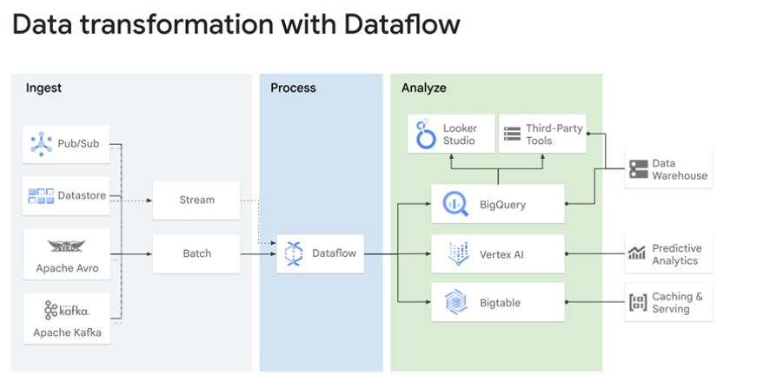

Dataprep Apr 20, 2026
Cloud Dataprep is a serverless, intelligent data service designed to visually explore, clean, and prepare both structured and unstructured data for analysis, reporting, and machine learning.
Cloud Dataprep Features
- It automatically suggests data transformations with each user input, eliminating the need for coding.
- It includes automatic schema detection, data type identification, possible joins, and anomaly detection to speed up data profiling.
Integration and Management
- Cloud Dataprep is operated by Trifacta and integrated with Google Cloud for a seamless user experience without software installation or licensing hassles.
- It is fully managed and scales on demand to accommodate growing data preparation needs.
Typical Use Case Architecture
- Raw data from sources like BigQuery, Cloud Storage, or file uploads can be prepared using Cloud Dataprep.
- The cleaned data can then be ingested into pipelines such as Cloud Dataflow and exported back to BigQuery or Cloud Storage for further analysis and machine learning.
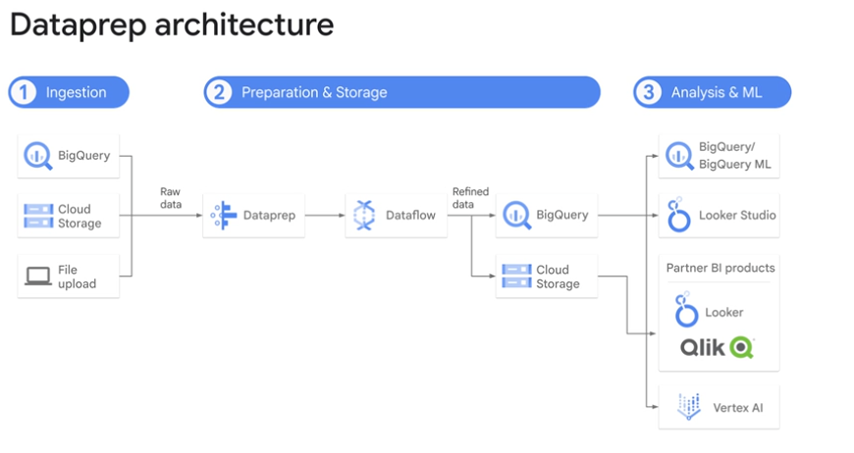
Dataproc Apr 20, 2026
Cloud Dataproc is a managed cloud service designed to simplify running Apache Spark and Apache Hadoop clusters with fast startup, scaling, and shutdown times.
Cloud Dataproc Features
- It offers per-second billing and cost savings through the use of preemptible instances.
- Clusters start, scale, and shut down in about 90 seconds, reducing wait times compared to traditional setups.
Integration and Management
- Cloud Dataproc integrates with other Google Cloud services like BigQuery, Cloud Storage, and Stackdriver for a comprehensive data platform.
- It allows easy cluster management and cost control by enabling clusters to be turned off when not in use.
Use Cases and Comparison
- Existing Spark, Hadoop, Pig, or Hive users can migrate to Cloud Dataproc without changing tools or APIs.
- When choosing between Cloud Dataproc and Cloud Dataflow, consider dependencies on Hadoop/Spark tools and whether you prefer a hands-on (Dataproc) or serverless (Dataflow) approach.
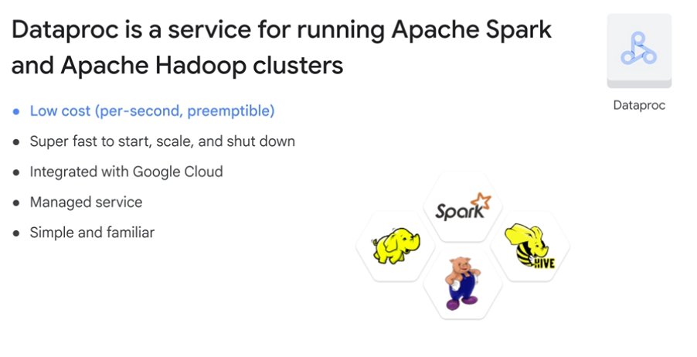

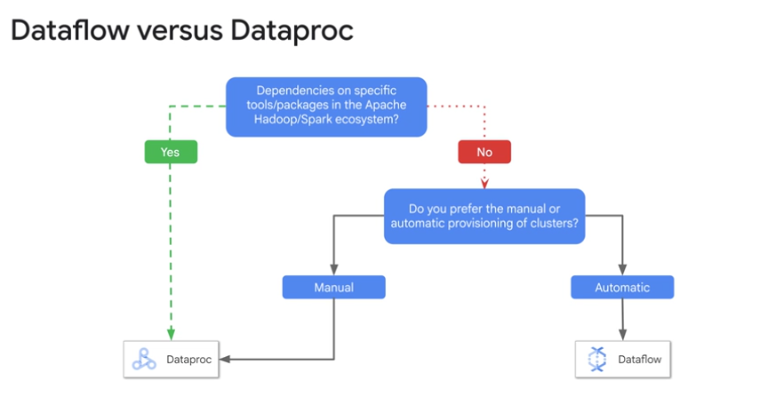

Demo: Dataproc Apr 20, 2026
This lecture explains how to create, manage, and use a Cloud Dataproc cluster on Google Cloud Platform (GCP) for running Apache Spark jobs.
Creating and Configuring a Cluster
- Navigate to Cloud Dataproc in the GCP console and create a new cluster by specifying a name and default settings such as region, zone, machine types, and number of worker nodes.
- Advanced options include setting preemptible nodes, network configurations, storage buckets, and encryption, but the example uses default settings.
Managing Cluster Nodes
- After the cluster is created, you can view the underlying Compute Engine instances representing the master and worker nodes.
- The number of worker nodes can be modified dynamically by editing the cluster configuration, which triggers the creation or removal of worker instances.
Submitting and Monitoring Jobs
- Jobs can be submitted to the cluster through the Dataproc interface by specifying job type (e.g., Spark), main class, arguments, and jar files.
- The example job calculates an estimate of pi, and job status and output can be monitored in the console.
Cluster Cleanup
- Once jobs are complete, the cluster can be deleted to stop billing and remove all associated resources, including Compute Engine instances.

